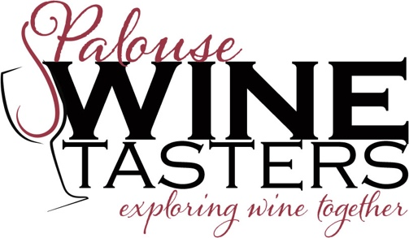
What: Spanish Wines from Galicia and Valencia
When: Sunday, May 15, 2022 at 3 pm
Where: The Mika’s back patio, 620 Ridge Road, Moscow
Cost: $38 per person. Please email Tim Steffens (timsteffens@mac.com) that you are coming.
Contact: Peter Mika (pmika@uidaho.edu)

So, you think you’re familiar with Spanish wines. I’m sure you’ve tried Spanish Tempranillo, Garnacha, and Monastrell. But have you ever had Mouratón, Bastarda, Mandó, or Arcos? And for whites, you’ve probably drank Albariño, Verdejo, and Viura (Macabeo), but not Palomino, Godello, Tortosí, Trepadell and Merseguera. Come to this event and broaden your wine tasting experience with wines from grapes of which you’ve probably never heard.
The wines come from Galicia in the northwest and Valencia in the southeast of Spain. We’ll have 3 flights of wine: 1) 4 whites from Galicia and Valencia, 2) 4 reds from Galicia, and 3) 4 reds from Valencia. All this will be accompanied by a Spanish-themed dinner: a tomato-based gazpacho with the whites and Shaun’s famous paella and a green salad with the reds. This will be followed by a Pedro Ximénez dessert sherry and a chocolate cake to cap off the afternoon.
Attendees will need to bring their own service, including silverware, plates, and bowl. Hope to see you there!The event will be outdoors on our covered patio, so if the weather is cool or hot, dress appropriately. Im looking forward to a great time and seeing you there.
Peter Mika

To reserve a spot (limited to the first 24 people), mail in this coupon and your check to (and email Tim Steffens, timsteffens@mac.com):
Palouse Chapter, PO Box 8274, Moscow, ID 83843

-----------------COUPON--------------------------------------------------------------------------------------------------------------
Wanting to begin tasting wines again I will attend the Spanish Wines from Galicia and Valencia on Sunday, May 15, 2022 at 3 pm. I have enclosed a $_______ check for ____ people (@$38/person). It will be held at The Mika’s back patio, 620 Ridge Road, Moscow. Please make checks payable to "Enology Society, Palouse Chapter".
Name ___________________________________________________________________
Street____________________________________________________________________
City _____________________State ____________________Zip ___________
Phone: Daytime ___________________________Nighttime __________________
email address_________________________________________________________
-----------------COUPON--------------------------------------------------------------------------------------------------------------

