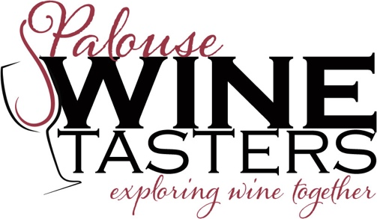
The Event:

What: 1988-89 Rhones
When: Saturday, January 26th at 7:00pm
Where: Unitarian Church of the Palouse, 420 E. 2nd St., Moscow
Cost: $23 for members, $26 for guests

Wines from a cross-section of the Rhone Region from two strong vintages. The wines include Guigal Cote du Rhone, Guigal Cote Rotie, Verset Cornas, Domaine Jean-Louis Chave Hermitage, Domaine du Cayron Gigondas, and Chateau de Beaucastel Chateauneuf du Pape. Come join us for an unparalleled opportunity to sample truly fine wines.

Please send registration to: Palouse Chapter, PO Box 8274, Moscow, ID 83843
Make checks payable to Palouse Chapter/Enological Society

The Unitarian Church does not sponsor this event.

For more information, please contact Peter Mika at 882-1862
Yes, we are coming to the Rhone tasting. I have enclosed a $_______ check for _______ members (@$23) and _______ guests (@$26).
Name: _______________________________________ Phone: _________________

